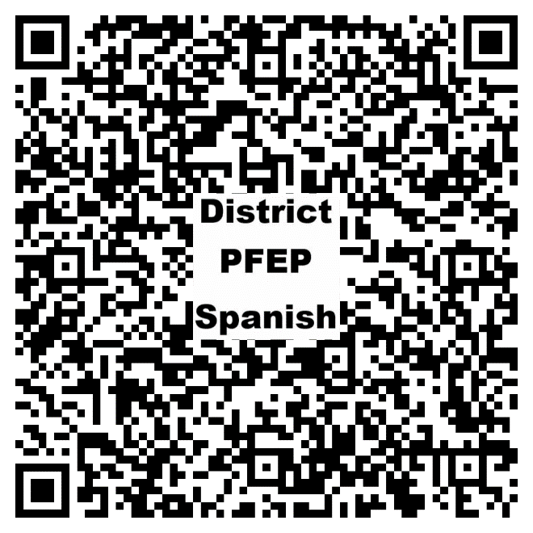
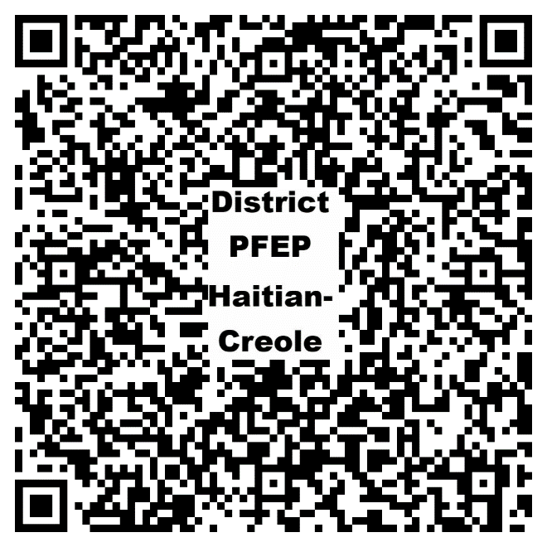

Learn how the District is conducting outreach to all parents and family members to implement programs, activities, and procedures that promote parent and family engagement.

