Home / Join Together / Cities Across U.S. See Rise in Synthetic Marijuana Overdoses

Cities Across U.S. See Rise in Synthetic Marijuana Overdoses
/BY JOIN TOGETHER STAFF
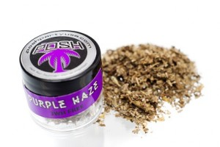
Officials in cities across the United States are reporting a rise in overdoses related to synthetic marijuana, CNN reports. Police chiefs meeting in Washington this week said they need field tests to help them quickly determine whether suspects have taken the drug.
Synthetic marijuana, sold under names such as “K2,” “Spice” and “Scooby Snax,” is very different from marijuana, according to the American Association of Poison Control Centers. It is made with dried herbs and spices that are sprayed with chemicals that induce a marijuana-type high when smoked. The drug is not tested for safety, so there is no way for a person to know what chemicals they are using.
Health effects can include severe agitation and anxiety; fast, racing heartbeat and high blood pressure; nausea and vomiting; muscle spasms, seizures, and tremors; intense hallucinations and psychotic episodes; and suicidal and other harmful thoughts and/or actions.
From January 1 to August 2, 2015, poison control centers received calls about 5,008 exposures to synthetic marijuana, compared with 3,682 in all of last year. According to a survey of 35 major city police departments, 30 percent have attributed some violent crimes to synthetic marijuana, the article notes. Overdoses in some cities are clustered in homeless populations.
On Tuesday, New York Police Commissioner William Bratton called the drug “weaponized marijuana,” and called it “a great and growing concern.”
The products are widely available, despite laws prohibiting them. With the passing of each regulation to control synthetic marijuana, drug manufacturers and suppliers are quickly changing the ingredients to new, non-controlled variations. For more information about this and other dangerous substances, click on http://www.drugs.com/illicit/synthetic-marijuana.html

