SOFTBALL STUDY GUIDE

BRIEF HISTORY

Softball is a variation of the game of baseball, which was derived from the English game of cricket. Abner Doubleday is the man credited with the invention of the game of baseball. However, historically this has been questioned.

GENERAL INFORMATION (there are two types of softball - slow pitch and fast pitch)
****(Important) Girls’ scholarships are only given out for FAST PITCH.****

1. A softball (slow pitch) team consists of 10 players, (fast pitch has 9 players). Each player
is given a specific number for scoring purposes as follows:
1 pitcher 6 shortstop
2 catcher 7 left fielder
3 first baseman 8 center fielder
4 second baseman 9 right fielder
5 third baseman 10 short fielder

2. An official game consists of seven innings. If the last team up at bat is leading, it is not
necessary to finish the second half of the seventh inning. Some leagues have a 10 or 15 run rule. This means that after 5 innings if a team is ahead by 10/15 runs the game is over.

3. Equipment includes; Softball (there are two types - 11” or 12” in circumference)
Gloves (five separate fingers, pitcher must have a solid color)
Mitt (2 or 3 fingers – used only by catcher & first baseman)
Bats, bases, catcher’s masks, etc.

4. PITCHING REGULATIONS
a. must start with one foot on the pitchers plate (in class, behind the ROPE)
b. may take only one step toward home before releasing the ball
c. ball must be pitched underhand
d. once a pitch is started, the ball must be thrown
e. the ball must have a 3 to 10 foot arch on it or be 6 to 12 feet from the ground
f. if a pitcher violates any of these rules, a ball is awarded to the batter. For a – d (above) each base runner is also entitled to advance one base (this is called a balk)

5. A STRIKE is called when:
a. the batter swings at a pitched ball and misses
b. the ball goes over any part of the plate between the knees and shoulders of the
batter (only in effect if there is an official umpire)
c. a foul ball is hit (not caught) - except on the third strike
d. a foul tip occurs (see # 14)
e. 3 strikes and the batter is out (Fast Pitch – 3rd strike rule is in effect)

6. A BALL is called (only when there is an official umpire)
a. the ball does not go over the plate between the batter's knees and shoulders
b. the pitcher pitches an illegal pitch
c. 4 balls and the batter walks (jogs)
d. In fast pitch, if the batter is hit by a pitched ball, he walks. In slow pitch if the batter makes an effort to get out of the way & is still hit then he walks (jogs) to first.

IN CLASS, WE use SLOW PITCH RULES
7. A FAIR HIT ball is a legally batted ball that
a. touches or goes over first or third base
b. lands and stays in the infield
c. lands in the outfield

8. A FOUL BALL is one that
a. lands in fair and rolls foul in the infield before a fielder touches it
b. lands in foul territory in the outfield

9. The BATTER is out when he/she
a. swings and misses on the third strike(unless 3rd strike rule in effect - fast pitch)
b. bunts foul on the third strike (only in fast pitch)(slow pitch – no bunting)
c. a foul or fair fly ball is caught
d. the ball reaches first base and is caught before the runner gets there (a tie goes
to the runner)
e. hits a foul tip on the third strike(see # 14)
f. is tagged with the ball off base (can overrun first base, but must make no attempt or fake to go to second when returning to first)
g. steps out of the batter's box as the ball is contacted
h. runs into his own batted ball before a fielder touches the ball
i. bats out of order
j. throws the bat

10. The BASE RUNNER is out when he/she
a. steps on a base that another base runner is occupying
b. runs into a batted ball that has not been touched by a fielder
c. is tagged with the ball when off base
d. the baseman has the ball and steps on the base that the runner is forced to go to (A Force Out)
e. runs out of the baseline to avoid a tag
f. leaves the base before the ball crosses the plate in slow pitch (before it leaves
the pitcher's hand in fast pitch)

11. SLIDING is legal in official softball games on an official field with a backstop and umpire. However, It WILL NOT be allowed in class.

12. STEALING is not permitted in slow pitch. It is legal in fast pitch if there is an umpire and the
game is being played on an official field.

13. OVERTHROW is a ball that is thrown past the fielder and into foul territory. (The runners may advance one base when this happens)

14. FOUL TIP is a ball that is tipped by the batter and goes directly back into the catcher's mitt,
it is ALWAYS a strike.

GROUND RULES
1. If any SAFETY rule is broken an out will be called. (i.e.shoes not tied, chewing gum, not standing behind the backstop, etc.)
2. A ball is called when the pitcher bounces the ball on home or between home and the pitcher's
mound.
3. Two fouls on the third strike is an out
4. If 10 batters have batted & there are still not 3 outs switch sides anyway.
5. When not batting, stay behind the backstop or the designated area or you will be out - - - -
no "on-deck" batters.
6. If you are behind the backstop & your team is not batting you will receive an “F” for the day.
7. No bats in the behind the backstop.
8. Any equipment not in use must be placed next to the back stop.
9. All equipment must be counted & put away BEFORE the win is recorded & students are dismissed.

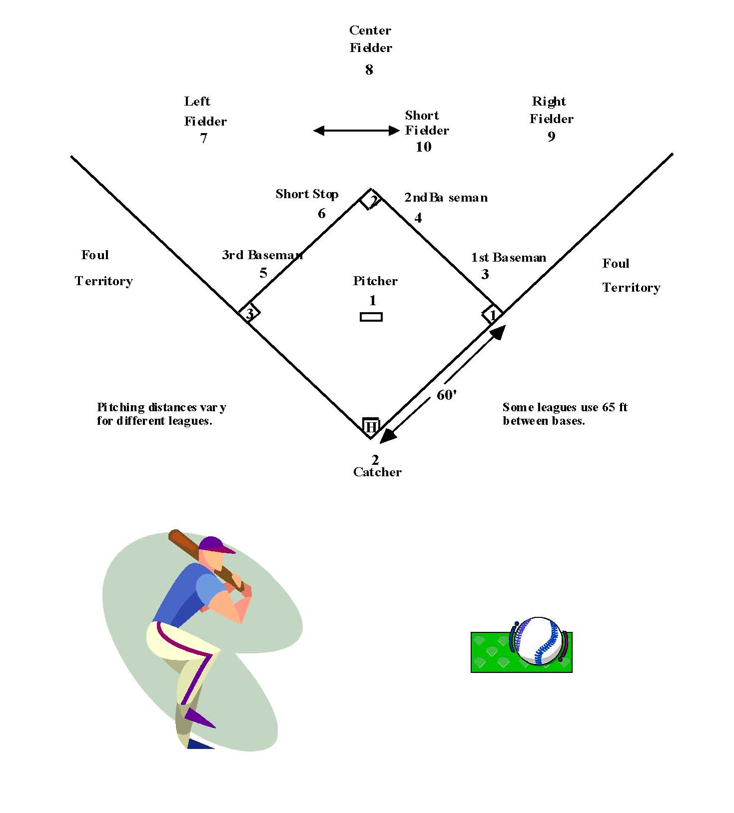
Revised 11/30/15

