SOCCER STUDY GUIDE
BRIEF HISTORY
Soccer is known as "football" in European countries where it is the number one spectator sport. Soccer is a running and kicking game where the ball is controlled by the feet. There is much doubt as to where and how the game was started, but it is known that the early Greeks and Romans played kicking games. The Irish claim to have played kicking games thousands of years before the Romans. The English Public Schools developed football games (any game played by kicking a ball) and the games of American football, rugby and soccer derived from these games.
SAFETY RULES
- No slide tackling in class
- No direct free kicks in class (only indirect kicks - no walls)
- Do not try to trap the ball by placing your foot directly on top of the ball.
- Do not watch the ball when dribbling - look up to see where you are going.
- Once the goalie touches the ball, no one is allowed to kick it. BACK AWAY - DO NOT TRY TO KICK THE BALL IF THE GOALIE IS ON THE GROUND. Do not charge the goalkeeper.
- No-one is permitted to block a goalie's kick - it is dangerous!!
- Wear shin guards, if you have them.
- Do not crowd around the ball.
- When heading the ball, be sure to keep your mouth closed, tongue in, head rigid and contact the ball at the hairline. DO NOT HEAD A LOW BALL.
Heading is not permitted in class.
- Do not jump at an opponent.
- Keep one foot on the ground while kicking.
- Keep your eyes on the ball when trapping, kicking or heading the ball.
- DO NOT HANG ON GOAL POSTS.

GAME
An official game of soccer consists of 2 periods of 45 minutes each. The object of the game is to move the ball toward the opponent's goal and to score by sending the ball into the goal. There are 11 players on an official soccer team. Different coaches use various types of line-ups (3-4-3, 4-3-3). For class, you are responsible for:
3 forwards 1 sweeper
3 mid-fielders 1 goalkeeper
3 defenders
Defenders are also called fullbacks. Sweepers are used in the backfield or in the front depending upon the coach. Remember, games are dynamic. They change over time as more people play and new ideas are introduced. You may be familiar with other terms and other line-ups. This is not wrong, it’s just different!!
GENERAL RULES
- The game is started with a kick off from the center of the field. The ball must go one revolution in a forward direction before it can be played by another player. The center forward cannot kick the ball again until another player has touched it. All players must be outside the circle on a kick off.
- The attacking team is the team in possession of the ball (offense).
- The defending team is the team trying to prevent the other team from scoring (defense).
- A goal/penalty kick counts as 1 point.
- Players may not use their hands or forearms to play the ball. This is illegal whether or not it is intentional.
6. Out of Bounds- lines are considered in bounds (if the ball rolls on the line it is still in play.)
    - if the ball goes out of bounds over the touch line (sideline), the opposite team is awarded a throw in. On a throw in, both hands must be used, the ball must be thrown overhead and both feet must stay in contact with the ground.
    - if the attacking team kicks the ball out of bounds over the goal line, the defense is awarded a goal kick. A goal kick is taken by any player from the top corner of the goal box on the side the ball went out. (if the ball went out on the right, then the ball is put on the top right corner of the goal box, if out on the left, the top of the left corner etc.)
    - if the defending team kicks the ball out of bounds over the goal line, the offense is awarded a corner kick. A score can be made directly from a corner kick.
    - if two players kick the ball out of bounds at the same time, the ball is put into play with a drop ball.

7. Goalkeeper
- is permitted the use of hands to play the ball, but only in the penalty area
- may throw, drop kick or punt the ball
- is not permitted to roll the ball forward and then pick it up again

8. If a foul occurs on the field of play, the opposite team is awarded a free kick on the spot. All players must be 10 yards away from the ball on a free kick.
direct kick - the ball can be scored directly from the free kick. (There are NO Direct Kicks in class)
indirect kick - the ball must be touched by another player before the score.
9. Fouls - a free kick is awarded to the opposite team on the spot. If the defense fouls in the penalty area, the offense is awarded a penalty kick
Some fouls are:
pushing, charging, holding, tripping, hitting, hands, kicking another player, dangerous kicks (high kicks, above your waist)
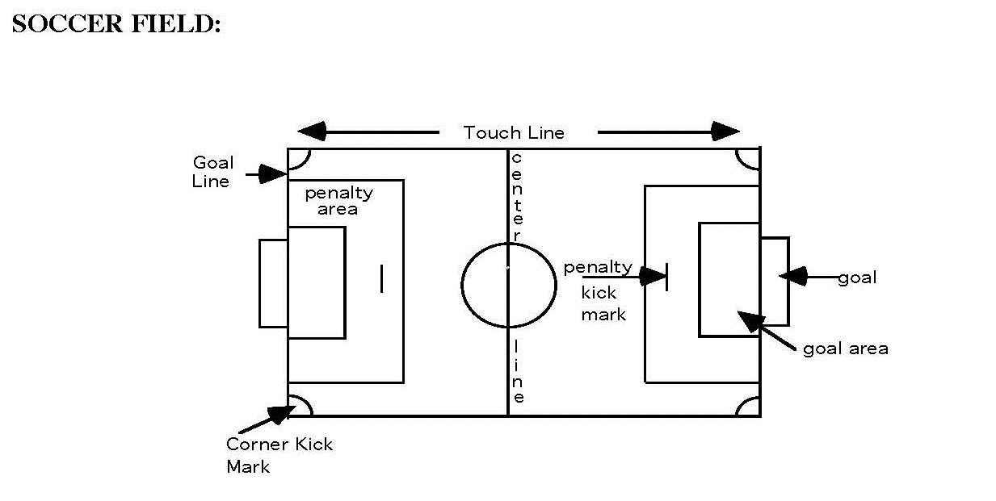

Revised on 11/30/15

