http://www.miamiherald.com/news/local/crime/article36723141.html
SEPTEMBER 26, 2015

The China pipeline, part 3: The deadly toll of synthetic drugs in South Florida
Synthetic drug-related deaths, nearly 300, on rise in Miami-Dade, Broward
Heroin substitute fentanyl, not infamous flakka, is deadliest
Experts: Untested chemical concoctions reduce users to “guinea pigs”
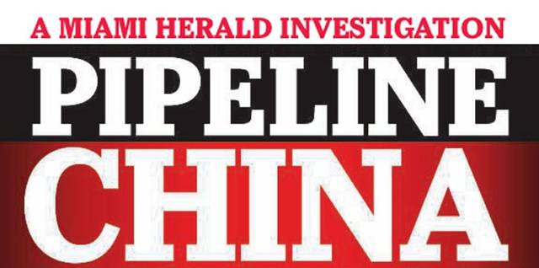
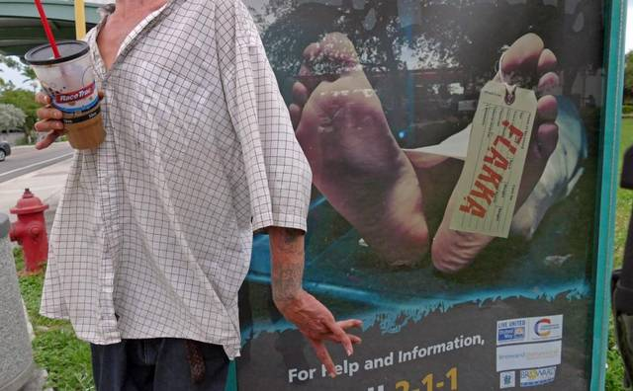
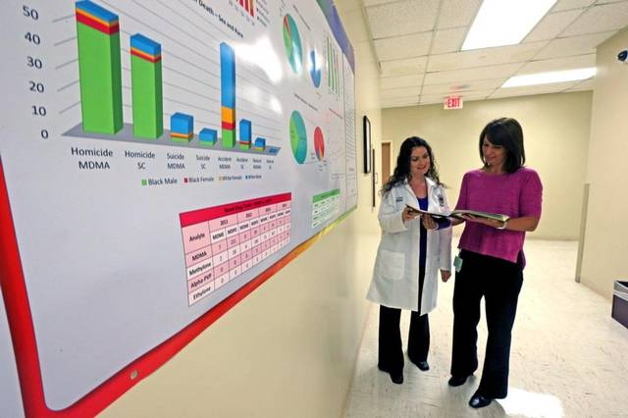

1 of 12
A flakka dealer named Ben high on the drug was stopped next to a Broward public service ad in Pompbano Beach by Broward sheriff’s Lt. Osvaldo Tianga earlier this month. Tianga called in paramedics to take him to the hospital. Walter Michot MIAMI HERALD STAFF
BY JAY WEAVER AND DAVID OVALLE
jweaver@MiamiHerald.com

  - LINKEDIN
  - GOOGLE+
  - PINTEREST
  - REDDIT
  - PRINT
  - ORDER REPRINT OF THIS STORY
Third in a three-part series.
Jordan Hirschfeld, a graduate of Michael Krop High who hoped to one day become a lawyer like his father, died in a Brickell apartment, the syringe still stuck in his arm after injecting a synthetic heroin called fentanyl. He was 28.
Java Jackson, high on the synthetic drug flakka, screamed at deputies and a medical crew that a snake was spitting acid on him and his clothes were burning before his over-revving heart failed at Broward Medical Center. He was 26.
Shaun Cole, a Scottish soldier attending the electronic music fest Ultra, had downed booze, cocaine and the synthetic drug ethylone before he plunged to his death from atop a Biscayne Boulevard office building. He was 22.
The drug deaths of the three young men this year shared a common thread, one that ties them to scores of other overdose, suicide, accident and even murder victims in Miami-Dade and Broward counties: The synthetic substances medical examiners found in their bodies most likely arrived though the China Pipeline, which delivers illegal drugs, sold as bulk research chemicals on the Internet, to stateside dealers through the mail.
Authorities are scrambling to shut down the pipeline but they acknowledge that it remains the primary source of an array of dangerous so-called designer drugs flowing into South Florida. The grim result: a rising number of addicts, emergency room visits and deaths — particularly related to newer, more potent synthetics like infamous flakka and the less known —but even more lethal —fentanyl.
“This is Breaking Bad gone wild,” said George Hime, assistant director of the Miami-Dade County Medical Examiner’s toxicology lab. “There is no quality control. They don’t even know what they’ve created. Is it something that can cause pleasure for a short period of time? Yes. But it could also kill you.”
Flakka has run rampant among the homeless and in poor corners of Broward, offering a cheap and powerful rush aptly described as “$5 insanity.” Flakka, street slang for a chemical called alpha-PVP, induced one man up the coast in Brevard County to strip, proclaim himself the Norse god Thor and try to have sex with a tree. Two other men, suffering a serious flakka-fueled lapse in judgment, tried to break into Fort Lauderdale police headquarters.
Fentanyl users haven’t produced such attention-grabbing crazy rages, but the drug has quietly proven even deadlier in South Florida, according to a Miami Herald review of medical examiner records in both Miami-Dade and Broward counties. A fast-acting painkiller 50 times more potent than heroin, it has been used as a surgical analgesic for decades.
But investigators believe that underground labs in China fueling the synthetics pipeline have concocted illegal fentanyl as well as chemically tweaked “analogs” that are typically sold as heroin or mixed with it.
“Fentanyl and its analogs are often laced in heroin and are extremely dangerous, more so than alpha-PVP,” said Diane Boland, director of the Miami-Dade Medical Examiner’s toxicology lab. “People are dying at an alarming rate, especially those who believe they are using heroin when it’s in fact fentanyl. A small dose is enough to cause death.”
PEOPLE ARE DYING AT AN ALARMING RATE, ESPECIALLY THOSE WHO BELIEVE THEY ARE USING HEROIN WHEN IT’S IN FACT FENTANYL.
Diane Boland, director of the Miami-Dade M.E.’s toxicology lab
One offshoot — “beta-hydroxy-thiofentanyl” — was ordered from China last year by dealers in North Dakota (where it led to two overdose deaths), Oregon and Canada, who authorities say intended to ship it to Florida for sale. That was the same substance that had filled the syringe found in the cold arm of Jordan Hirschfeld.
His father, Neal Hirschfeld, a Fort Lauderdale lawyer, had never heard of fentanyl before it killed his son. “We had no experience with synthetics from China. I was completely shocked.”
And the Hirschfelds were unfortunately far better educated than most about addiction, having helped Jordan through battles with marijuana, alcohol and anti-anxiety medication. Jordan — described by his mother, Caryl Rapplean, as “full of life . . . tall, handsome, funny, smart” — had repeatedly tried to break the cycle at a boot camp in Utah, a rehab facility in Malibu and numerous local treatment centers.
“It was a battle we just couldn’t win,” his father said. “We tried everything and lost.”

Fast-rising death toll from fentanyl
While alcohol, prescription pills and established drugs like pot and cocaine still show up more frequently in toxicology reports, synthetics have been on a rapid rise that has alarmed police, the medical community and public health experts in South Florida. Medical examiner records in the two counties show that one or more of the most common synthetics have been detected in nearly 300 victims since 2011.
Jordan Hirschfeld fell victim to what has emerged as the deadliest designer drug. In less than a year going back to October 2014, fentanyl has outright killed or contributed to the overdose deaths of 53 people in Miami-Dade. Broward recorded 30 fentanyl-related deaths between June 2014 and June of this year alone. Jordan was the first of eight to die from the variant “beta-hydroxy-thiofentanyl,” which also has killed at least four other people in Broward.
FENTANYL HAS KILLED OR CONTRIBUTED TO THE OVERDOSE DEATHS OF AT LEAST 53 PEOPLE IN MIAMI-DADE AND 30 IN BROWARD IN ABOUT A YEAR.
Stefano Rotati of Pinecrest, a 29-year-old University of Miami graduate with model good looks and a promising musical career as a drummer, was another fentanyl fatality. In May, he collapsed inside a Miami apartment and later died at Jackson Memorial Hospital.
Audrey Rotati said her son had struggled with prescription painkiller abuse after injuring his back when his car was rear-ended a few years ago, but she didn’t believe he would knowingly take a risk on synthetic heroin.
“My little piece of heaven on Earth. He really was a sweet guy,” she said. “I’m 99.9 percent sure he didn’t know it was fentanyl he had taken.”
Flakka also has taken a heavy toll, particularly in Broward, where it has been linked to 43 fatalities in the last year, a figure that leads the nation and has drawn national media coverage. Many victims have been street people with addiction histories, but at least one baby, who died in July of prematurity at birth, also had the drug in his system. Flakka also has been present in 19 deaths in Miami-Dade since 2013.
But in both counties, flakka has rarely been cited as the sole or primary cause of death, instead usually listed among multiple drugs that ultimately proved toxic.
Java Jackson was Broward’s lone straight-out flakka overdose. On Memorial Day, a Broward Sheriff’s Office report described him at a Dania Beach home as screaming for his mother, hallucinating about an acid-spitting snake and burning clothes. He was, deputies reported, “extremely combative” during an ambulance ride. At the Broward Medical Center, his mother “pleaded” to have her 26-year-old son, who she said had been previously hospitalized after a flakka frenzy, committed for substance abuse treatment.
It was too late. He died the same day.
Months later, reached by phone, Erica Jackson said she was still too distraught to talk about her son. “It still brings up open wounds for me,” she said last week.

Overdoses reflect only part of the impact
Medical examiners, public health experts and law enforcement agencies stress that overdoses from a single drug reflect only a small part of the impact of the new wave of Chinese-made synthetics.
Flakka and other drugs often play a contributing role in a fatality, part of a cocktail of alcohol and other drugs that can turn lethal or trigger pyschotic behavior. For example, no one can say for sure why Shaun Cole, the Scottish soldier at Ultra, decided to climb atop a building or if he fell or jumped. But blood from his broken body contained alcohol, cocaine and ethylone, a synthetic often sold as the club drug Molly.
Molly, the catch-all name for a number of euphoria-inducing drugs popular in dance clubs and at concerts, also has been detected in at least 135 homicide, suicide and accidental deaths in Miami-Dade since 2011. (The Broward medical examiner’s office said it was unable to provide statistics for Molly-related deaths over the same period.)
That number is not surprising. Law enforcement agencies say drugs marketed as Molly remain the most prevalent synthetics in South Florida. They are offshoots of European-made MDMA, usually known as ecstasy, which had dominated the designer-drug scene during the previous decade.
Molly consisted mainly of methylone until a 2014 ban imposed in China and the United States. Chemists quickly skirted it by simply tweaking the formula to produce a similar substance called ethylone.
Sometimes called bath salts, both drugs are classified as synthetic cathinones, derived from the Middle Eastern khat plant. Overdose deaths directly attributed to Molly are less common, according to toxicologists, but still happen. In 2013, a 21-year-old Ultra music fan named Anthony Cassano began showing signs of “erratic behavior” before he was rushed to the hospital. Cause of death: “methylone toxicity.”

Untested, unknown chemicals add to risk
But experts say pills hawked as Molly, like other synthetics, often contain untested or unknown chemicals or ingredients — either blended in the lab or mixed in by dealers to stretch a supply and profits. Small Chinese labs, operating with little regulation, have unleashed so many variations that scientists stateside studying effects can’t keep up.
CHINESE LABS HAVE UNLEASHED SO MANY VARIATIONS THAT SCIENTISTS STATESIDE STUDYING EFFECTS CAN’T KEEP UP.
The scant research has generally been on small rodents and isolated human cells, said Gregory Dudley, a professor of chemistry and biochemistry at Florida State University who has testified in Molly-related court cases.
“There is frighteningly little research, particularly when it comes to human users,” Dudley said. “We just don’t know. Any reasonable person can conclude they are probably dangerous, and certainly there is anecdotal evidence, but we can’t quantify the dangers.”
It can take years for toxicologists to even figure out what some victims have taken.
George Salgado, a 21-year-old Miami fitness instructor, believed he was taking three tabs of LSD in April 2012. Afterward he stripped off his clothes and, eyes bulging and skin pouring sweat, attacked a man. He died after a police officer shot him multiple times with a Taser, his body temperature spiking to 105 degrees. Toxicologists couldn’t initially identify the drug.
That same year, teenage college students Marco Pomares and Hector Miranda vanished in a marshy area of West Miami-Dade after inhaling an unknown drug . They were later found, dead from exposure.
This year, the county medical examiner’s office developed more sophisticated testing protocols and was able to identify the same drug in both cases: a powerful synthetic hallucinogen called 25I-NBOMe.
A similar drug, 25C-NBOMe, was detected in the brain of graffiti artist Israel “Reefa” Hernandez-Llach, who died after being shot with a Taser by a Miami Beach police officer in 2013. The medical examiner ultimately ruled the cause of his death was heart failure from the “energy device discharge.”
Deborah Mash, a brain researcher at the University of Miami who has studied the effects of synthetic drugs, describes users in two words: “Guinea pigs.”
“It’s very, very scary,” she said. “We don’t know the potency, and we don’t know what’s in them.”

Flakka’s addictive appeal: Cheap, powerful rush
Still, for some hard-core users, the bang for the buck overrides the risks.
Flakka, which means “skinny” in Spanish, has been slow to spread in Miami-Dade, where law enforcement authorities say Molly remains queen of the club scene. But it took off in Broward’s transient and drug-addicted population as authorities shut down prescription-drug “pill mills” peddling painkillers.
FLAKKA SEIZURES HAVE SOARED IN BROWARD, FROM ZERO IN 2013 TO 800 SO FAR THIS YEAR.
Flakka seizures have mushroomed since in Broward, soaring from zero in 2013 to 200 last year. So far this year, the Broward Sheriff’s Office crime lab has examined 800 seizures.
Christopher Patterson, 26, of Miami, who said he has used a variety of narcotics, including heroin, since he was 15, had a relapse with flakka while undergoing drug treatment in Broward earlier this year. It was cheap, easily available and not detected on many drug tests.
On a flakka binge, he wound up wandering the drug dens of Pompano Beach, paranoid and filled with a maddening rush of calm euphoria and superhuman strength before returning to rehab.
“It was this mixture that felt like ecstasy, Molly, cocaine and crack. It was like this weird combination feeling that I just did not enjoy,” Patterson said in an interview at the Cove Center for Recovery in Fort Lauderdale. “But being an addict, knowing it wouldn’t show up on my drug test, it was so cheap I used it a few times before I was caught.”
Mash, the UM brain researcher, described flakka — which can be smoked, snorted, swallowed or injected — as “super coke.” At higher doses, the drug can deliver an overload of pleasure-inducing dopamines to the brain and a sense of super strength, but that can come with dangerous side effects of soaring fever, rapid heart rate and paranoia. She suggests that in some people, flakka has led to “excited delirium,” a brain disorder characterized by the bizarre rampages that have made headlines across the state.

‘Say no 2 flock’
Faced with what amounts to a flakka epidemic in some neighborhoods, Broward Sheriff Scott Israel and local officials this year launched a series of law-enforcement sweeps and community forums. One major goal is to keep the stuff out of schools and the hands of kids.
WHILE IT ISN’T A PROBLEM WITH SCHOOLS RIGHT NOW, I’D BE WATCHING FOR IT. . . . A VERY LITTLE AMOUNT, AND YOU’RE OFF TO THE RACES.
Craig Mallak, Broward Medical Examiner
“It’s coming in green and blue and yellow and red [tablets]; they’re adding fruit colors to it,” Broward Medical Examiner Craig Mallak said at one public forum this summer. “While it isn’t a problem with schools right now, I’d be watching for it because we’re going to start seeing it. . . . A very little amount, and you’re off to the races.”
Broward has produced a series of chilling public service ads posted in flakka hot spots, including bus stops. The posters, headlined “Lose your mind, lose your life,” show a corpse with a toe tag that reads “flakka.” In one gritty Pompano Beach warehouse district, locals constructed their own ad: red plastic cups in a chain-link fence spelling out: “Say no 2 flock.”
It’s not yet clear how well the messages are getting through.
During one early summer patrol, Broward Sheriff’s Lt. Osvaldo Tianga, who specializes in flakka and other synthetic drugs, came across 26-year-old Jenika Senter. She had moved from New England to the Fort Lauderdale area to get treatment for her heroin addiction — only to fall prey to flakka.
The sunburned and tattooed woman sat in a wheelchair, the result of injuries suffered when a car hit her during an earlier flakka binge. First, Tianga tried persuading Senter to enter rehab, even calling her mother in New Hampshire. But when he stopped her later, he found she had a small plastic baggie of flakka hidden in her purse.
“What pisses me off is you have family who cares about you,” Tianga said. “I offered you help an hour ago, but you didn’t want it. You need to go to jail today.”
After spending more than a month in jail for drug possession, Senter was released and enrolled in a court substance abuse program. But in July, she was charged with prostitution and released again in August.
On another outing this month, Tianga spotted a dealer he knew. The man, named Benjamin, twitched repeatedly as he walked down Atlantic Boulevard. Tianga asked to touch his hand to check his temperature — a telltale sign. It was high, so he called Broward Fire Rescue to take the 32-year-old to a local hospital.
The encounter, ironically, occurred in front of one of the county’s anti-flakka posters. And it underlined a message Tianga often delivers at community forums. Cops can’t turn off the pipeline of flakka by themselves.
“We can’t beat this drug alone, I’m sorry,” Tianga told a gathering this summer in Oakland Park. “We need a partnership with the community. We need to be one.”
A THREE-PART INVESTIGATION
Part One: The China Pipeline: South Florida’s source of synthetic drugs
Part Two: The rise and fall of a young Molly kingpin
Part Three: The rising and deadly toll of synthetics in South Florida
Interactive map: Follow the Molly from China to Miami

RELATED CONTENT

South Florida man awaiting trial on charges of trafficking Molly

South Florida’s source for synthetic drugs: The China pipeline

The China pipeline, part 2: The rise and fall of a Molly kingpin

Read more here: http://www.miamiherald.com/news/local/crime/article36723141.html#storylink=cpy

