Volleyball Study Guide
GAME - 25 points (must win by 2 points) (Rally scoring)
MATCH - when a team wins 2 out of 3 games (3 out of 5 in upper level)
TEAM - consists of six players - they rotate in a circle going in a clockwise direction
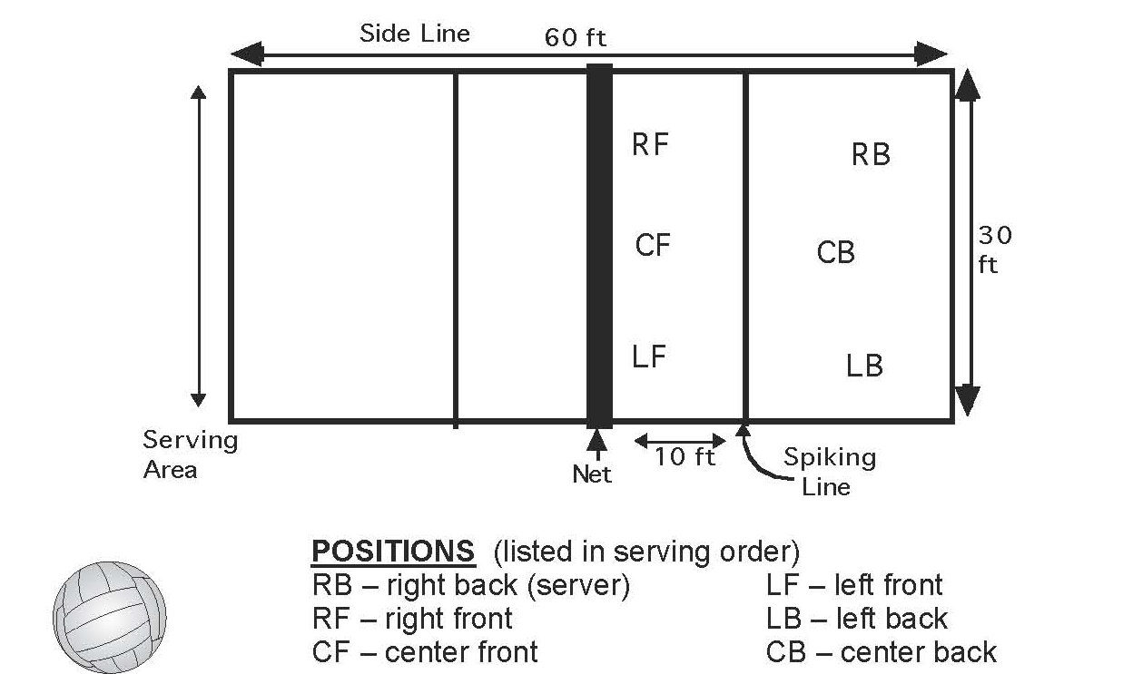
Rally Scoring – In Rally Scoring a point is scored on each serve, matches are 2 out of 3 games, games 1-2 go to 25 points, game 3 goes to 15 points.
A serve can touch the net and if it goes over, it remains in play.
(upper level matches are 3 out of 5 games, game 1 – 4 go to 25 points, game 5 is 15 points)

TERMINOLOGY
Serve - putting the ball in play over the net and into the opponents’ court by the right back.
The server must serve the ball in an area from between the right and left sideline,
provided he or she remains behind the end line. The ball can be served underhand or
overhand.
Round Robin Tournament - when every team plays every other team at least one time
Foot Fault - when the server steps on or over the end line while serving (side out)
Dead Ball - a ball temporarily out of play
Point - when the live ball is not returned over the net legally. Either the
serving team or receiving team can score points (rally scoring)
Side Out - when the serving team fails to win a point. The serve is given to the other team
Legal Hit - the ball is hit with any part of the body above the waist
Illegal Hit - when the ball comes to rest momentarily on any part of the body or is hit with
any part of the body below the waist
Out of Bounds - any surface or object outside the court except a player, playing the ball
Bump (forearm pass) - hitting a ball underhand with the forearms. It is the first hit used to
slow the ball down for your own team.
Set - a two-hand overhead hit. Places the ball up in position for your spiker.
Spike - a one-hand overhead hit. Hit hard downward at the other team for a point.
Note: There are many more types of legal hits, e.g. dink, dig, drive etc.
GENERAL RULES * Remember there are several sets of rules.
1. Teams change courts at the end of each game of the match. During the third game of
the match they re-toss a coin to determine choice of side or serve.
2. The server cannot step on or over the end line until the ball is served. (foot fault)
3. The players must be in bounds and in their positions on the serve.
4. Each team has 3 hits to get the ball over the net.
5. Each player is allowed only one hit in a row. If a player hits the ball and someone else
hits it, the first player may hit the ball again
6. A player may not lift, hold or push the ball.
7. The ball is dead once it hits any part of the body below the waist.
8. A ball that hits the net during play is good and may be played.
9. If a ball hits the net on a serve, whether in goes over or not, it is a net serve and
illegal or side out in Standard scoring but okay in Rally scoring if it goes onto the
court.
10. It is a violation if a player touches the net or steps over the centerline while the ball
is in play.
11. If two players hit the ball simultaneously (at the same time), it counts as one hit and
either one of them may hit it again.
12. A ball that lands on a line is good and play should continue. It is not a dead ball.
13. Players may run out of bounds to hit a ball but may not cross the center line.
14. It is illegal for back line players to run up in front of the 10 ft. spiking line (3 meter
line) to block or spike the ball or to make any offensive plays.
15. It is illegal to serve out of turn or to have someone else serve for you.

PLAYER ETIQUETTE
1. Roll the ball under the net when sending it to the other team.
2. Be courteous to officials, opponents and teammates.
3. Play your own position. Let everyone try to hit the ball - Remember, we learn from our
own mistakes. Help your teammates by encouraging them not discouraging them.
4. Call the score out before serving - say the servers score first.
5. Use common sense and good manners toward EVERYONE!

YOU CAN BE MORE COURTEOUS THAN THIS BUT NOT LESS
BRIEF HISTORY & DIMENSIONS
Volleyball was introduced by William J. Morgan in 1895 at the Y.M.C.A. in Holyoke, Mass. It has been an Olympic sport since 1964. The net height varies by men, women, & age.
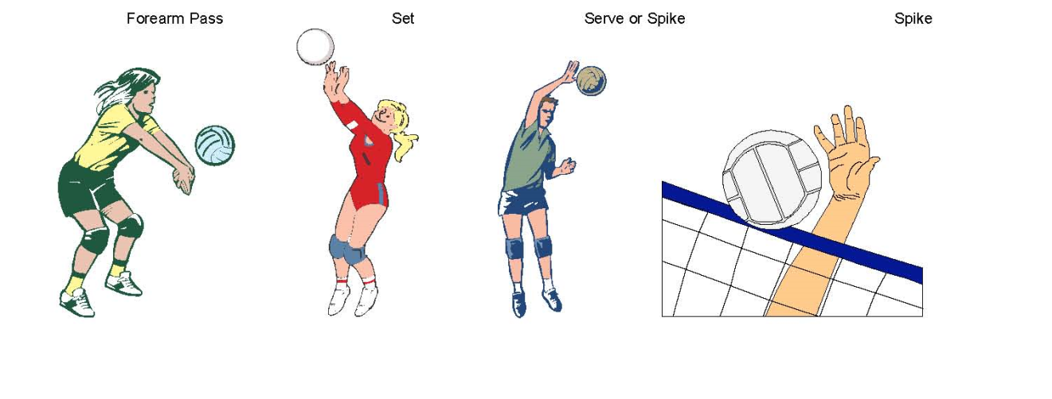 Revised 10/25/15

