Flag Football Study Guide
Safety Rules
1. Proper Physical Education uniform MUST be worn. Shoes must be tied. NO cleats are permitted.
2. The defense will line up 3 feet behind the line of scrimmage. (3 large steps)
3. Defense will use the 5 Mississippi rush on passing plays (count: 1 Mississippi, 2 Mississippi,
3 Mississippi, etc.) before rushing in. You do not need to count on running plays.
4. Blocking is done with the arms crossed and the elbows down against the chest.
5. NO rushing the kicker. ALL kicks are free kicks in flag football.
6. No leaving the feet when tackling. (tackling in flag football means pulling off the flag)
7. There will be no tackle football played in class. IF A TACKLE OCCURS, THE STUDENT
WILL RECEIVE AN "F" FOR THE UNIT AND WRITTEN WORK FOR THE
REMAINING TIME.
General Rules
1. There are 7 people on a flag football team and 11 on a tackle football team.
2. The kickoff is taken from the second cone. If the ball is kicked into the end zone on a kickoff or
a punt, it is a touchback and the player can elect to run it out or down the ball. If it is
downed, it is placed at the second cone.
3. A team has 4 downs to make a first down. A first down is achieved when you pass the nearest
cone after the original line of scrimmage. The line of scrimmage is an imaginary line where
the ball is placed after each play. It separates the offense and defense. Teams cannot pass the
line of scrimmage until the ball is hiked. The ball must stay on the ground until hiked.
4. Forward passes are illegal if you are in front of the scrimmage line when you pass.
5. ALL players are eligible to receive a pass.
6. A team has 30 seconds to make a play.
7. Tackling is done by grabbing the runner's flag and immediately throwing it to the ground.
You may only pull off the flag of the ball carrier. DEFENDERS CANNOT INTERFERE
WITH THE PROGRESS OF A BALL CARRIER. If your flag accidentally falls off, you are
considered tackled at the spot where the flag fell.
8. The flag must be worn on the outside of the apparel and must hang straight down.
A BALL CARRIER IS NOT ALLOWED TO PREVENT A DEFENSIVE PLAYER
FROM REMOVING THE FLAG. STIFF ARMING IS NOT PERMITTED.
9. As soon as the ball touches the ground it is DEAD. NO FUMBLES OR RECOVERIES!
THE TEAM WITH THE BALL KEEPS POSSESSION AND THE BALL IS PLACED AT
THE SPOT WHERE THE FUMBLE OCCURRED. On a snap from the center, the ball is
dead once it hits the ground. A player can pick up the ball on a punt or kickoff when it
bounces, if no other player has touched it.
10. A team must announce when they are going to punt. NO FAKES. DEFENSE CANNOT
MOVE UNTIL THE BALL IS KICKED.
11. A safety occurs when the offense is tackled in their own end zone. The defense scores 2 points
and they also receive the kick.
12. A touchdown scores 6 points. The point after touchdown is made by passing or running
(not kicking). A team must attempt the extra points (there are no free points) A pass is
worth one point and a successful run is worth 2 points.
13. The quarterback may run with the ball however, running plays are not allowed within one yard
on either side of the offensive center.
14. There are no time outs in class. Wait for the opponent to be set.
15. Additional info. may be found at http://ifaf.org the International Federation of American Football &
www.nationalflagfootball.com National Flag Football.
Penalties

Off Sides - 5 yards Equipment Violation – 5 yards
Illegal Block - 15 yards Not announcing a kick - 5 yards and loss of ball
Guarding your flag - 15 yards Pass Interference - automatic 1st down on the spot
Un-sportsmanlike conduct - 15 yards (out of the game in class)

Tackle Football Offensive Positions

Terms such as flanker, tight end, wing back, wide receiver, tailback, and split end are used
to denote where a particular back or end lines up on the field. There are also many “nicknames” that
are used. Different coaches use players in different ways. DO NOT assume you know everything
because coaches are continuously developing new ways to improve their team’s chances of
winning. We will use the following diagram to identify the football positions.

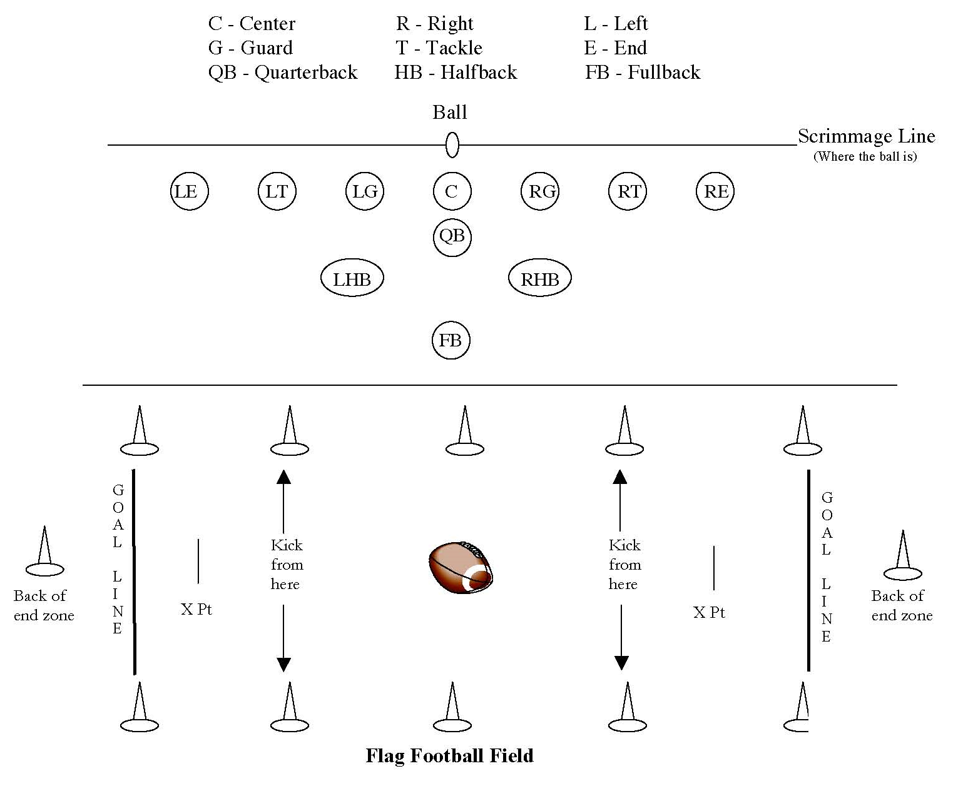

Revised 10/25/15

